**Evolutionary Divergence of ACE2 Receptors in Bats and Other Mammals: Implications for Coronavirus Host Interactions**

**Shilpa Sanapala**

**List of Contents**

Use of AI  
Executive Summary   
Introduction and Background  
Data Sources  
Data Preparation  
Methodology  
Results  
Discussion  
Conclusion  
References  
Appendix – Figures, tables, and visualizations (R code, Jalview saved views (.jvp folder; needs jalview online or desktop version), Excel and .fasta files (can be opened with a text editor) attached separately)

**Use of AI**

Artificial Intelligence (AI) and computational tools were used for this project to some extent. R packages such as Biostrings, msa, seqinr, ggmsa, and ggplot2 were used for performing (angiotensin-converting enzyme 2) ACE2 protein sequence alignments and entropy computations. Jalview was used extensively as a visualization tool for exploratory analysis. Annotations generated during this process were used to analyze the alignments and generate conservation heatmaps, phylogenetic trees, and consensus scores for both bat and non-bat ACE2 protein sequences. Elicit (an AI-powered search tool) was used as a semantic engine to conduct a comprehensive literature review and identify the key accession numbers for ACE2 protein sequences. When searching on the NCBI/protein database yielded unsatisfactory or ambiguous results, Elicit was also used to verify the accuracy and availability of experimental evidence for certain accession numbers. ChatGPT was used for troubleshooting core errors and certain package installations. When using ggmsa to facet the alignment output, the visualization was illegible and optimized with input from ChatGPT on how to map the colors to all amino acid residues and reduce clutter without removing relevant information. The integration of these tools enabled the creation of a high-throughput, reproducible analysis pipeline to detect evolutionary patterns.

**Executive Summary**

The threat of emerging coronaviruses is ongoing and necessitates a deeper understanding of how these viruses interact with host receptors across species. It is central to predicting zoonotic spillovers and developing preventative public health strategies (Plowright et al., 2021; Ruiz-Aravena et al., 2022). This project investigates the genetic diversity and evolutionary divergence of the ACE2 protein, the key receptor for SARS-CoV, SARS-CoV-2, and other related coronaviruses in bats and other mammalian species (Damas et al., 2020). The goal is to assess whether bats experience a higher selective pressure at ACE2 sites, potentially driven by long-term coevolution with coronaviruses.

The study leveraged several bioinformatics tools within R and outside to analyze ACE2 protein sequences from a curated list of 10 bat species and 10 non-bat mammals. Multiple sequence alignments were performed to compare the two groups and calculate per-site sequence entropy, consensus, and conservation metrics, as well as to identify amino acid positions that showed significant divergence. While mean conservation scores and entropy values were not statistically significant when the analysis was confined to 31 key amino acid residues, specific residues, such as Leu79, showed high divergence and aligned with experimentally verified viral binding sites in the spike region, suggesting their structural and functional relevance (Alexander et al., 2020). Thus, although bats are confirmed reservoirs of diverse coronaviruses, data from this analysis did not conclusively show a stronger selective pressure on bat ACE2 sequences relative to other mammals. However, the presence of highly divergent, functionally significant residues suggests localized adaptation, reflecting historical virus-host coevolution. Overall, the project provides a foundational framework for monitoring viral emergence risks through molecular evolution analysis, highlighting the role of ACE2 variability in determining cross-species transmission potential.

**Introduction and Background**

Bats are a major reservoir for coronaviruses with pandemic potential (Ruiz-Aravena et al., 2022). To date, three highly pathogenic betacoronaviruses have spilled over into humans: severe acute respiratory syndrome coronavirus (SARS-CoV), SARS-CoV-2, and Middle East respiratory syndrome coronavirus (MERS-CoV). Bats comprise over 1400 species and represent about 20% of all mammals. They are highly diverse in their ecology, phylogeny, and behavior (El Sayes et al., 2024). Understanding the evolutionary interactions between bats and the viruses they harbor is essential to identifying the underlying mechanisms of viral emergence, adaptation, and interspecies transmission.

ACE2 is a membrane-bound host protein that serves as the entry receptor for both SARS-CoV and SARS-CoV-2 (Starr et al., 2022). The spike protein of these coronaviruses binds to the host ACE2 receptor to gain entry into mammalian cells, making ACE2 the focal point of several host susceptibility and interspecies transmission studies. ACE2 variability among species can influence binding affinity and therefore, determine host range (Demogines et al., 2012; Wrobel et al., 2023). Several mutational analyses and structural studies have identified critical amino acid residues in the ACE2 protein that modulate virus-receptor interaction, including sites such as K31, Y41, and N330 (Li et al., 2005; Shang et al., 2020). Bats exhibit a broad range of ACE2 sequence variation and are hosts to multiple SARS-related coronaviruses, which share close to 78-96% sequence identity with human SARS-CoVs, increasing concerns about future spillover. Thus, the viral diversity and host receptor polymorphism drive an evolutionary arms race, resulting in signatures of selection on both virus and host genomes (Guo H, et al).

The rationale of this project is to check whether bats and other mammals are evolving in response to coronaviruses, and if bat ACE2 receptors show evidence of stronger selection. By comparing bat and non-bat ACE2 protein sequences, this study aims to check evolutionary features, such as divergence in key receptor binding residues, indicating ongoing host adaptation. The study contributes to the broader understanding of virus-host coevolution and informs public health surveillance to better anticipate and equip against potential spillovers as well as guide vaccine and therapeutic development efforts against zoonotic coronaviruses.

**Data Sources**

Data Collection:

Sequence retrieval was performed using the NCBI/protein database. Bat and non-bat ACE2 protein sequences (10 each) were downloaded in FASTA format by entering a known accession number from the literature or by using targeted search queries such as: “Rhinolophus sinicus”[Organism] AND ACE2 to filter for a specific species and ACE2 protein. The criteria for inclusion when choosing the species were: Taxonomic diversity (to include species from both major bat suborders: Yinpterochiroptera and Yangochiroptera), ecological diversity (different diets, habitats, behaviors). It also prioritized species known to harbor SARS-related viruses or with available full-length ACE2 sequences.

Data Preparation

All downloaded sequences were saved into two master FASTA files: bat_ACE2.fasta and non-bat_ACE2.fasta. Headers were standardized to include species names. Sequences were aligned using msa package, specifically the MUSCLE algorithm in R (Edgar, 2004). The outputs from the multiple sequence alignments were saved and visualized using Jalview (Waterhouse et al., 2009). Annotations and phylogenetic trees were exported from Jalview for further analysis.

**Methodology**

A comparative bioinformatics pipeline was developed to focus on protein sequence diversity and divergence between bat and non-bat mammals. This analysis comprised multiple stages:

1. Multiple Sequence Alignment (MSA): The sequences were aligned using the MUCLE algorithm implemented via the msa package. Aligned sequences were exported in FASTA format for compatibility with both analysis as well as visualization tools. The alignment process ensured accurate residue positioning across species and minimized potential biases introduced by insertions and deletions. Jalview allowed grouping by species, annotation of consensus sequence, and color-coded phylogenetic trees, as well as percentage identity visualizations.
2. Entropy and Conservation Analysis: The aligned sequences were converted into a matrix format in R using the Biostrings and seqinr packages prior to calculating per-site sequence variability by Shannon entropy. Higher entropy scores indicated greater sequence diversity at that site. Entropy values were calculated separately for bat and non-bat alignments. Conservation scores and consensus residues (the most frequently occurring amino acids at each position) were also examined at each site. The scores (on a scale of 0-11) reflected the degree of conservation of amino acid residues across species in each group. Changes in dominant residues between groups were detected by evaluating the consensus table exported into Excel from Jalview.
3. Divergence Metric and Site Ranking: A composite metric was developed to quantify divergence between bats and non-bats. This metric combined three components for each amino acid position:
   1. Consensus difference: Binary variable (1 = different consensus residues, 0= same)
   2. Entropy difference: Absolute difference in Shannon entropy values between bat and non-bat groups.
   3. Scaled conservation difference: Weighted absolute difference in conservation scores between groups.

The custom divergence score enabled ranking of sites by their evolutionary difference, with higher scores indicating greater divergence.

**Results**

The comparative analysis of ACE2 protein sequences between bats and other mammalian species yielded several key insights into evolutionary divergence and potential functional relevance at specific amino acid residues. In total, 31 ACE2 positions with known or predicted involvement in the receptor-binding domain (RBD) binding were evaluated.

Conservation heatmaps: Conservation scores exported from Jalview and a color-coded conservation map was created. Positions in red (scores 0-3) were classified as highly divergent, yellow (4-6) as moderately conserved showed, and green (7-11) as highly conserved. The analysis showed that most ACE2 residues were highly conserved across mammals (both bats and others), with average scores ranging between 7 and 11. However, several positions, especially those involved in the viral spike binding, displayed notable divergence in both consensus residues and conservation. 21 out of 31 residues showed a different consensus residue between bats and non-bats.

Entropy values: Per-site sequence variability calculations indicated both bat and non-bat groups to have a mix of conserved and variable regions. The mean entropy values for bats and non-bats were 0.74 and 0.61 respectively, which were not statistically significant (Student’s t-test, p=0.24).

Divergence score: This score was computed by integrating the entropy scores, conservation scores and consensus data for each amino acid position. The score showed that certain key amino acid residues involved in the viral spike binding, such as 79, 31, 41, etc, exhibited greater divergence.

**Discussion**

The evolutionary interplay between host receptors and coronaviruses is central to understanding zoonotic emergence, particularly in species like bats that serve as natural reservoirs for diverse and potentially pathogenic viruses. Many of the divergent positions corresponded to functionally and structurally important regions within the ACE2-spike protein interaction interface. Position 79 showed the highest divergence, supporting previous published findings that this site is highly variable across ACE2 orthologs and may affect virus-host interactions (Alexander et al., 2020; Low-Gan et al., 2021). Other highly divergent residues 27, 31, 41, and 330 are also part of the ACE2 interface known to interact with SARS-CoV and SARS-CoV-2 RBDs (Ye et al., 2021; Jafary et al., 2021). As 21 out of 31 residues showed a different consensus residue between bats and non-bats, it appears there is a significant shift in amino acid preference, indicating possible host-specific adaptation. These results support the hypothesis that while overall ACE2 conservation is high among mammals, specific residues, particularly some that interact with viral RBD, show higher divergence. There are a few methodological limitations to this study. The sample size of 10 for each group may not be sufficient to see any significant differences in conservation and entropy scores. A few coronaviruses use DPP4 instead of ACE2, and thus, the results from this study cannot be generalized to all bat species. Lastly, the absence of structural modeling restricts the ability to directly infer binding affinities or fitness implications of the observed mutations.

**Conclusion**

This study set out to explore whether bats are under a greater selection pressure in the ACE2 protein region, compared to other mammals. The overall conservation and entropy levels did not appear to be significantly different between bats and non-bats. However, several key residues exhibited marked divergence at known viral binding sites. This divergence could reflect evolutionary responses to persistent viral pressure in mammals, and these findings underscore the need for targeted molecular surveillance and evolutionary analysis in predicting zoonotic spillover risks, species-specific vulnerabilities, and enhancing our public health strategies aimed at early detection, risk mitigation, and mitigation of emerging coronavirus threats.

**References**

**Alexander, M. R., Schoeder, C. T., Brown, J. A., Smart, C. D., Moth, C., Wikswo, J. P., Capra, J. A., Meiler, J., Chen, W., & Madhur, M. S.** (2020). Predicting susceptibility to SARS-CoV-2 infection based on structural differences in ACE2 across species. FASEB Journal, 34(12), 15946–15960. <https://doi.org/10.1096/fj.202001808R>

**Damas, J., Hughes, G. M., Keough, K. C., Painter, C. A., Persky, N. S., Corbo, M., ... & Lewin, H. A.** (2020). Broad host range of SARS-CoV-2 predicted by comparative and structural analysis of ACE2 in vertebrates. Proceedings of the National Academy of Sciences, 117(36), 22311–22322. <https://doi.org/10.1073/pnas.2010146117>

Demogines, A., Farzan, M., & Sawyer, S. L. (2012). Evidence for ACE2-utilizing coronaviruses (CoVs) related to severe acute respiratory syndrome CoV in bats. *Journal of Virology, 86*(7), 3659–3663. https://doi.org/10.1128/JVI.06540-11

Edgar, R. C. (2004). MUSCLE: Multiple sequence alignment with high accuracy and high throughput. *Nucleic Acids Research, 32*(5), 1792–1797. <https://doi.org/10.1093/nar/gkh340>

El Sayes, H., Ibrahim, R., Berto, A., & Müller, M. A. (2024). A global view of bat-borne coronaviruses and their spillover potential: Insights from molecular evolution. *Viruses, 16*(2), 214. <https://doi.org/10.3390/viruses16020214>

**Guo, H., Hu, B. J., Yang, X. L., Zeng, L. P., Li, B., Ouyang, S., & Shi, Z. L.** (2020). Evolutionary arms race between virus and host drives genetic diversity in bat severe acute respiratory syndrome-related coronavirus spike genes. Journal of Virology, 94(20), e00902–20. <https://doi.org/10.1128/JVI.00902-20>

**Jafary, F., Jafari, S., & Ganjalikhany, M. R. (**2021). In silico investigation of critical binding pattern in SARS-CoV-2 spike protein with angiotensin-converting enzyme 2. Scientific Reports, 11, 6927. <https://doi.org/10.1038/s41598-021-86380-2>

**Li, W., Zhang, C., Sui, J., Kuhn, J. H., Moore, M. J., Luo, S., Wong, S. K., Huang, I. C., Xu, K., Vasilieva, N., Murakami, A., He, Y., Marasco, W. A., Guan, Y., Choe, H., & Farzan, M.** (2005). Receptor and viral determinants of SARS-coronavirus adaptation to human ACE2. The EMBO Journal, 24(8), 1634–1643. https://doi.org/10.1038/sj.emboj.7600640

Low-Gan, J. V., So, P. L., Chan, K. H., Leung, G. M., & Yuen, K. Y. (2021). Diversity of ACE2 and its interaction with SARS-CoV-2 receptor binding domain. *Biochemical Journal, 478*(19), 3671–3692. https://doi.org/10.1042/BCJ20210533

**Plowright, R. K., Reaser, J. K., Locke, H., Woodley, S. J., Patz, J. A., Becker, D. J., ... & Hudson, P. J.** (2021). Land use-induced spillover: A call to action to safeguard environmental, animal, and human health. The Lancet Planetary Health, 5(4), e237–e245. https://doi.org/10.1016/S2542-5196(21)00031-0

Ruiz-Aravena, M., McKee, C., Gamble, A., Lunn, T., Morris, A., Snedden, C. E., ... & Becker, D. J. (2022). Ecology, evolution and spillover of coronaviruses from bats. *Nature Reviews Microbiology, 20*(5), 299–314. <https://doi.org/10.1038/s41579-021-00652-2>

**Shang, J., Ye, G., Shi, K., Wan, Y., Luo, C., Aihara, H., Geng, Q., Auerbach, A., & Li, F.** (2020). Structural basis of receptor recognition by SARS-CoV-2. Nature, 581(7807), 221–224. <https://doi.org/10.1038/s41586-020-2179-y>

Starr, T. N., Greaney, A. J., Hilton, S. K., Ellis, D., Crawford, K. H. D., Dingens, A. S., ... & Bloom, J. D. (2022). ACE2 binding is an ancestral and evolvable trait of sarbecoviruses. *Nature, 603*(7903), 913–918. https://doi.org/10.1038/s41586-022-04464-z

Waterhouse, A. M., Procter, J. B., Martin, D. M. A., Clamp, M., & Barton, G. J. (2009). Jalview Version 2—a multiple sequence alignment editor and analysis workbench. Bioinformatics, 25(9), 1189–1191. <https://doi.org/10.1093/bioinformatics/btp033>

Wrobel, A. G., Benton, D. J., Xu, P., Calder, L. J., Borg, A., Roustan, C., ... & Gamblin, S. J. (2023). Evolutionary optimization of coronavirus spike protein–ACE2 receptor interaction. *Nature Structural & Molecular Biology, 30*(3), 312–320. https://doi.org/10.1038/s41594-022-00865-2

**Ye, F., Lin, X., Chen, Z., & Liu, M.** (2021). S19W, T27W, and N330Y mutations in ACE2 enhance SARS-CoV-2 S-RBD binding toward both wild-type and antibody-resistant viruses and its molecular basis. Signal Transduction and Targeted Therapy, 6, 343. <https://doi.org/10.1038/s41392-021-00756-4>

|  |  |  |  |
| --- | --- | --- | --- |
| **Scientific Name** | **Common Name** | **Suborder** | **Accession Number** |
| **Rhinolophus sinicus** | **Chinese horseshoe bat** | **Yinpterochiroptera** | **ADN93475.1** |
| **Rhinolophus sinicus** | **Chinese horseshoe bat** | **Yinpterochiroptera** | **ADN93472.1** |
| **Rhinolophus ferrumequinum** | **Greater horseshoe bat** | **Yinpterochiroptera** | **ADN93470.1** |
| **Pteropus alecto** | **Black flying fox** | **Yinpterochiroptera** | **XP_006911709.1** |
| **Pteropus vampyrus** | **Large flying fox** | **Yinpterochiroptera** | **XP_011361275.1** |
| **Rousettus aegyptiacus** | **Egyptian fruit bat** | **Yinpterochiroptera** | **XP_015974412.2** |
| **Myotis lucifugus** | **Little brown bat** | **Yangochiroptera** | **XP_023609438.1** |
| **Myotis davidii** | **David’s myotis** | **Yangochiroptera** | **XP_015426918.1** |
| **Eptesicus fuscus** | **Big brown bat** | **Yangochiroptera** | **XP_008153150.2** |
| **Desmodus rotundus** | **Common vampire bat** | **Yangochiroptera** | **XP_024425698.2** |

**Appendix**

**Table 1.** Selected bat species with their ACE2 protein sequence accession numbers

|  |  |  |  |
| --- | --- | --- | --- |
| **Scientific Name** | **Common Name** | **Notes** | **Accession Number** |
| **Homo sapiens** | **Human** | **Reference species** | **NP_068576.1** |
| **Canis lupus familiaris** | **Dog** | **Domesticated carnivore** | **NP_001158732.1** |
| **Bos taurus** | **Cow** | **Livestock model** | **NP_001019673.2** |
| **Sus scrofa** | **Pig** | **Livestock; zoonosis studies** | **NP_001116542.1** |
| **Mus Musculus** | **Mouse** | **Model organism** | **NP_081562.2** |
| **Felis catus** | **Cat** | **Domesticated carnivore** | **NP_001034545.1** |
| **Macaca mulatta** | **Rhesus macaque** | **NHP model** | **NP_001129168.1** |
| **Pan troglodytes** | **Chimpanzee** | **Closest relative to humans** | **A0A2J8KU96** |
| **Rattus norvegicus** | **Rat** | **Common lab rodent** | **NP_001012006.1** |
| **Mustela putorius furo** | **Ferret** | **Model for respiratory virus research** | **NP_001297119.1** |

**Table 2.** Selected non-bat species with their ACE2 protein sequence accession numbers

|  |  |
| --- | --- |
|  | **Value** |
| **Mean_Conservation_Bat** | **8.322580645** |
| **Mean_Conservation_NonBat** | **8.387096774** |
| **Mean_Entropy_Bat** | **0.743914678** |
| **Mean_Entropy_NonBat** | **0.612500732** |
| **Num_Positions** | **31** |
| **Num_Consensus_Different** | **21** |
| **Num_Consensus_Same** | **10** |

**Table 3.** Summary statistics for conservation, consensus and entropy analysis

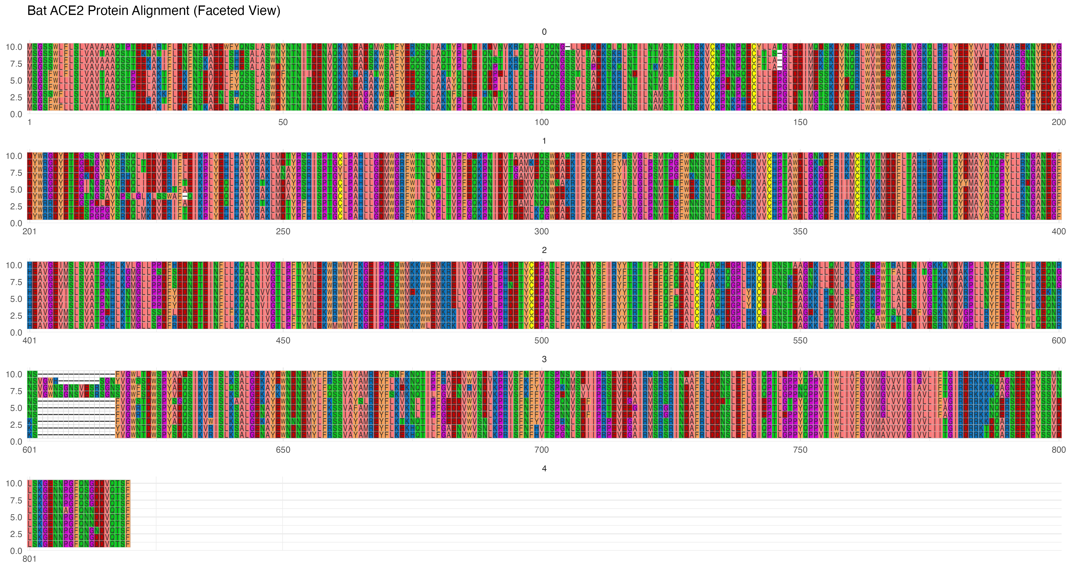

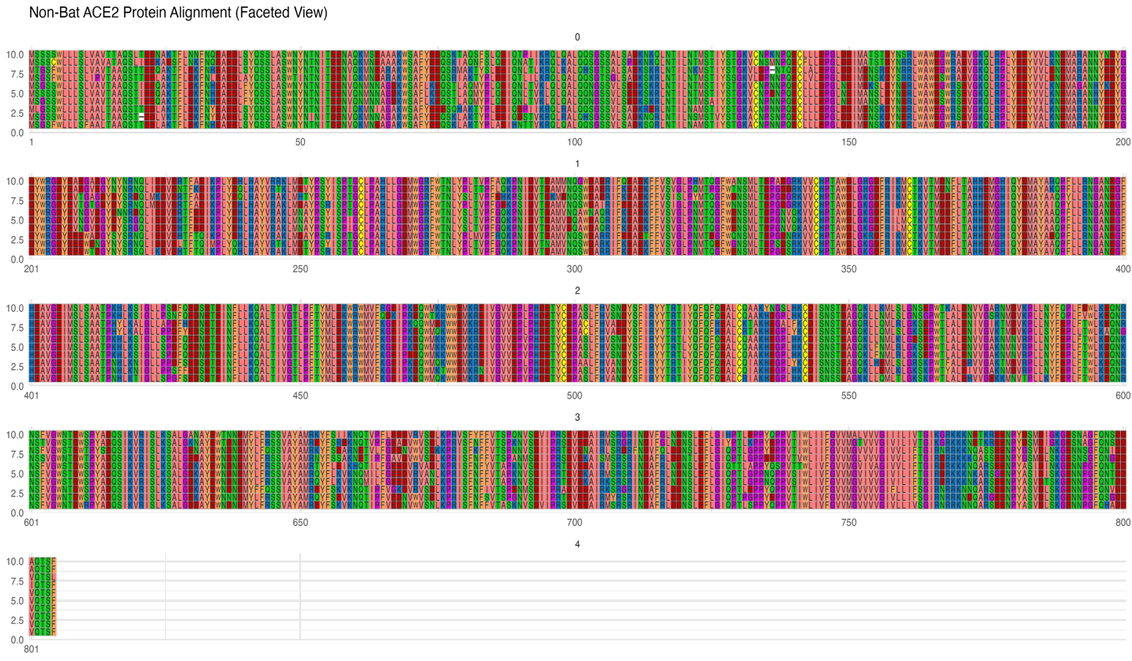

**Figure 1.** Alignment of bat and non-bat ACE2 protein sequences (visualization in R)

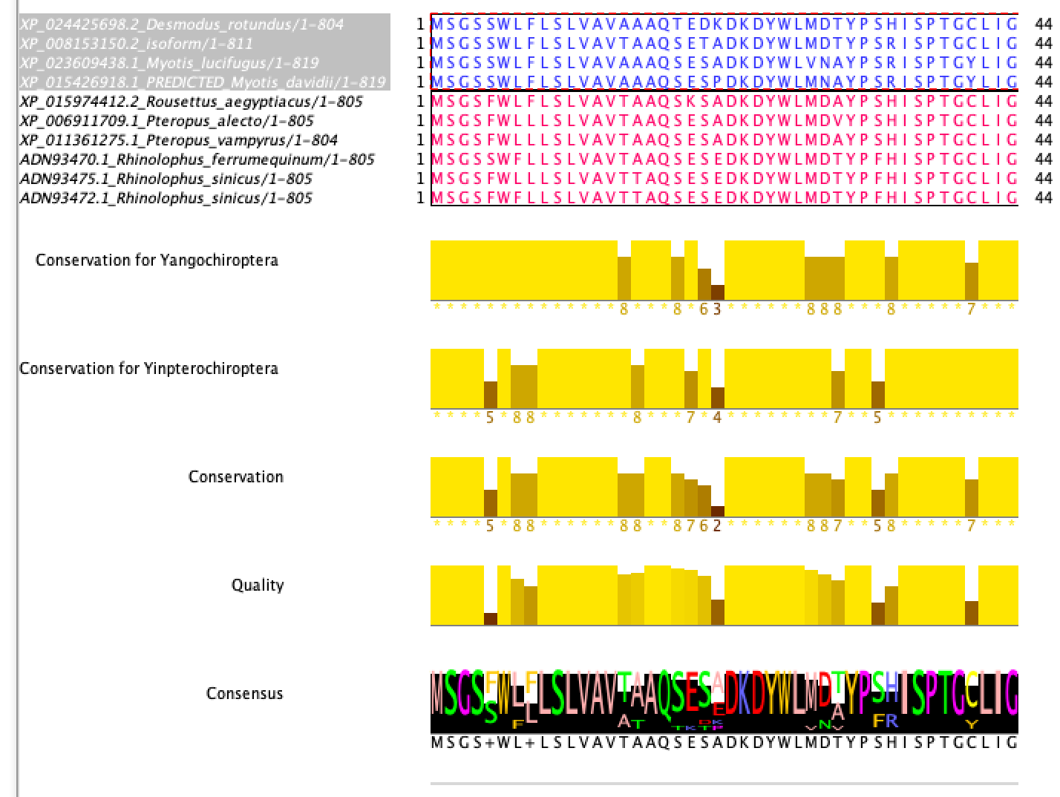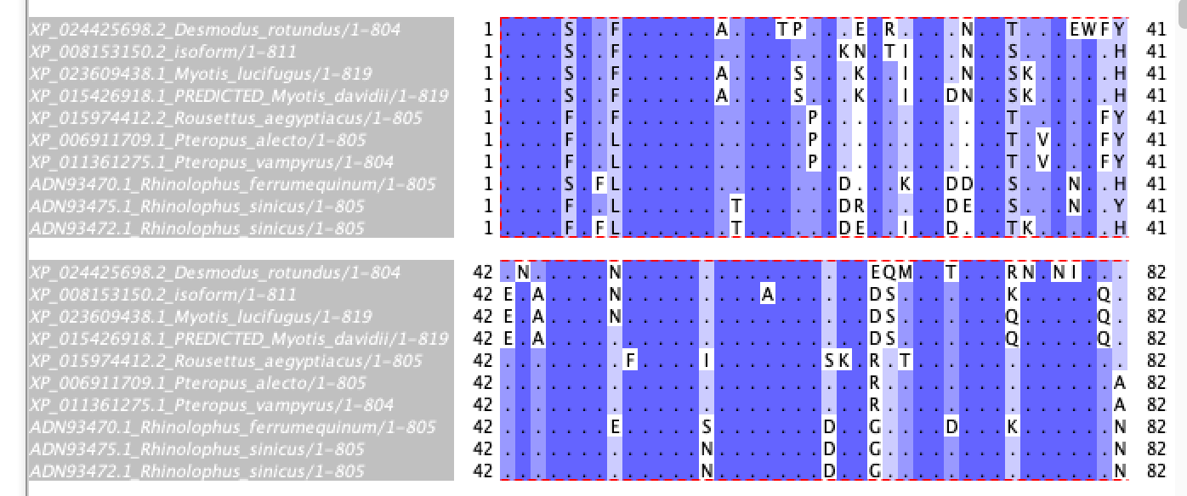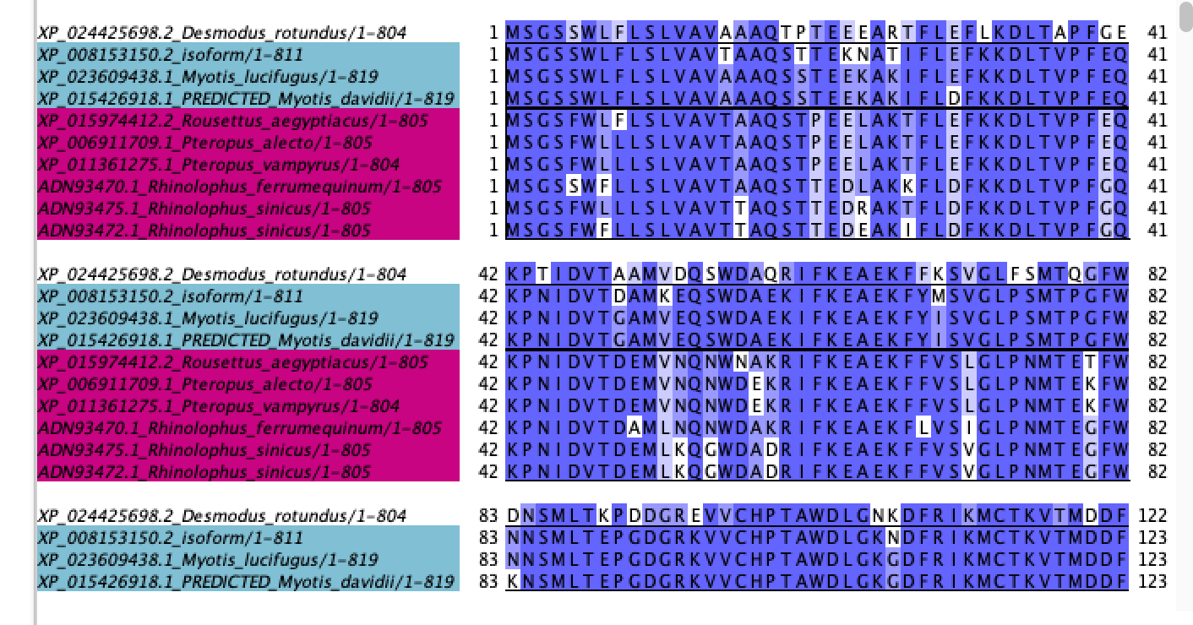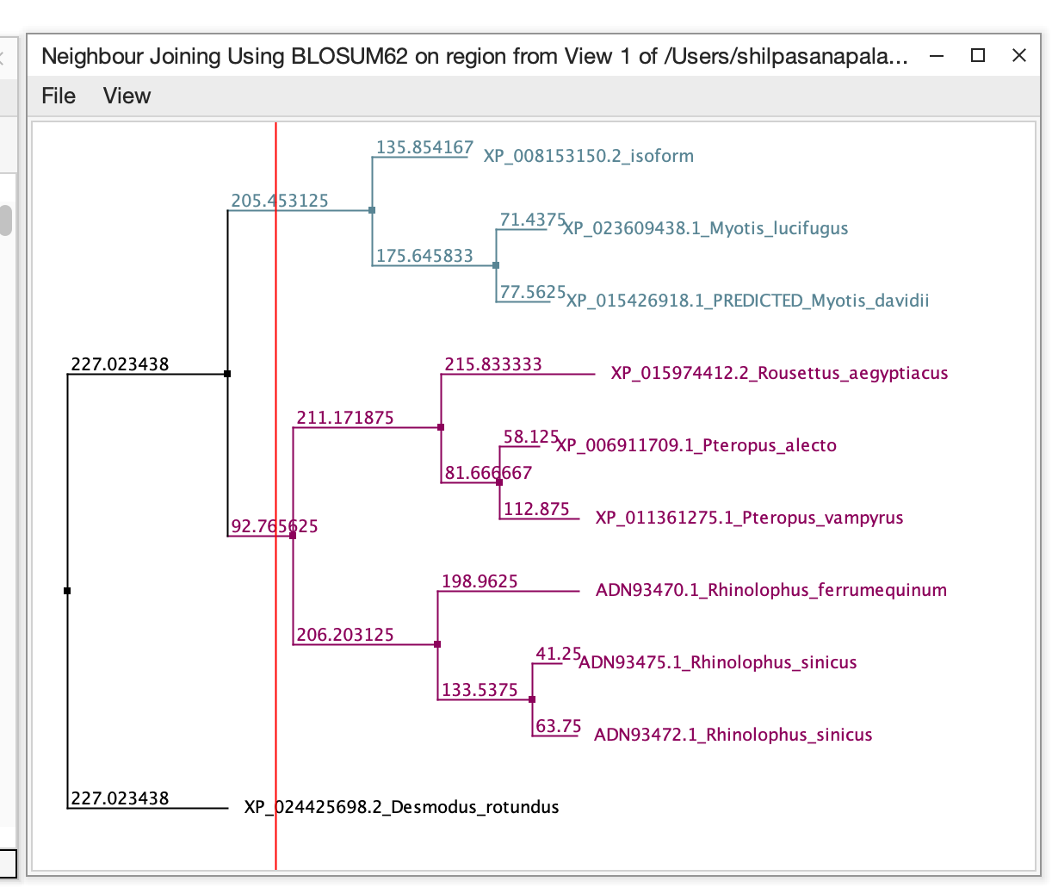

**Figure 2.** Alignment of bat ACE2 protein sequences (visualization in Jalview) plus phylogenetic tree

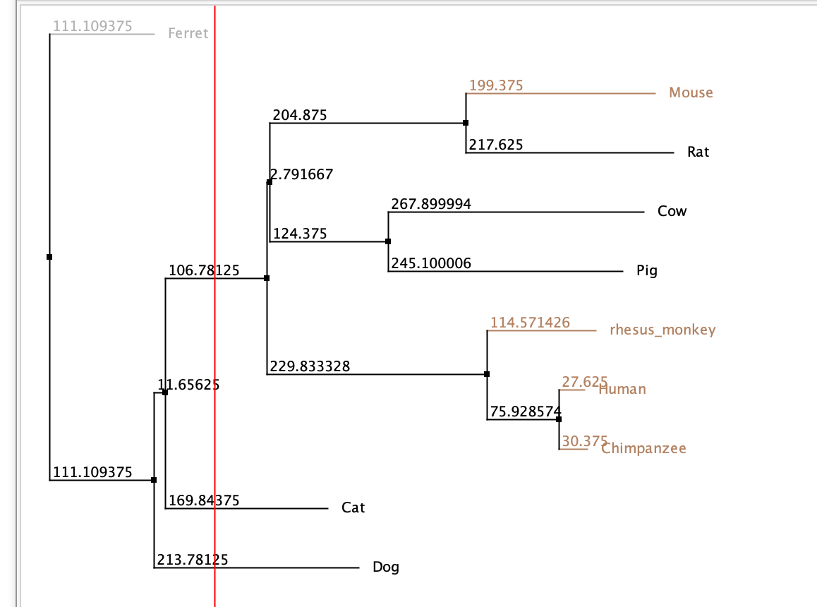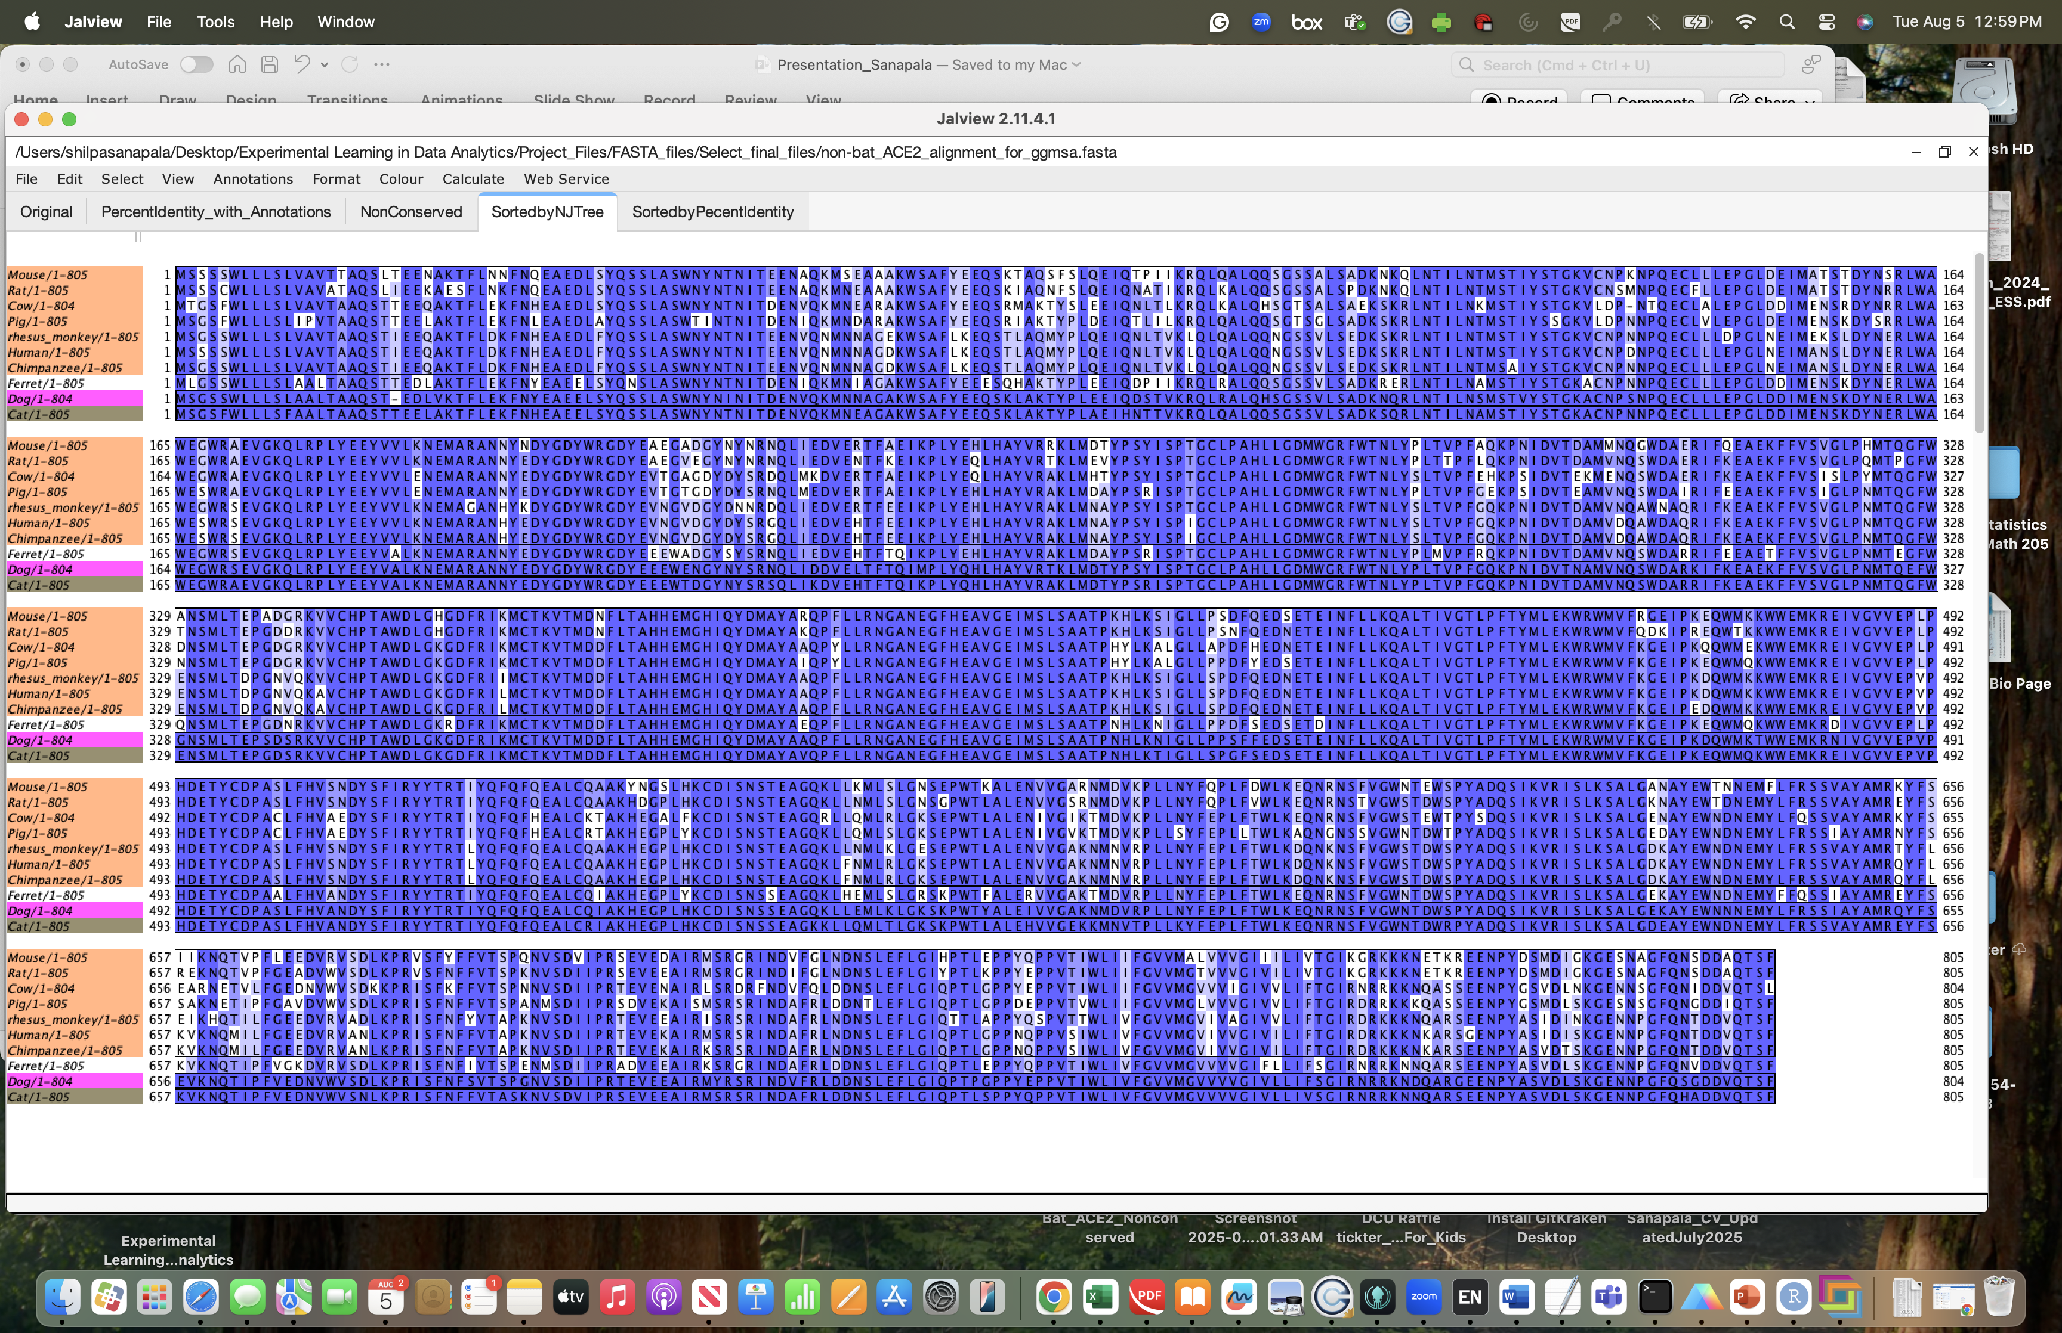

**Figure 3.** Alignment of bat ACE2 protein sequences (visualization in Jalview) plus phylogenetic tree

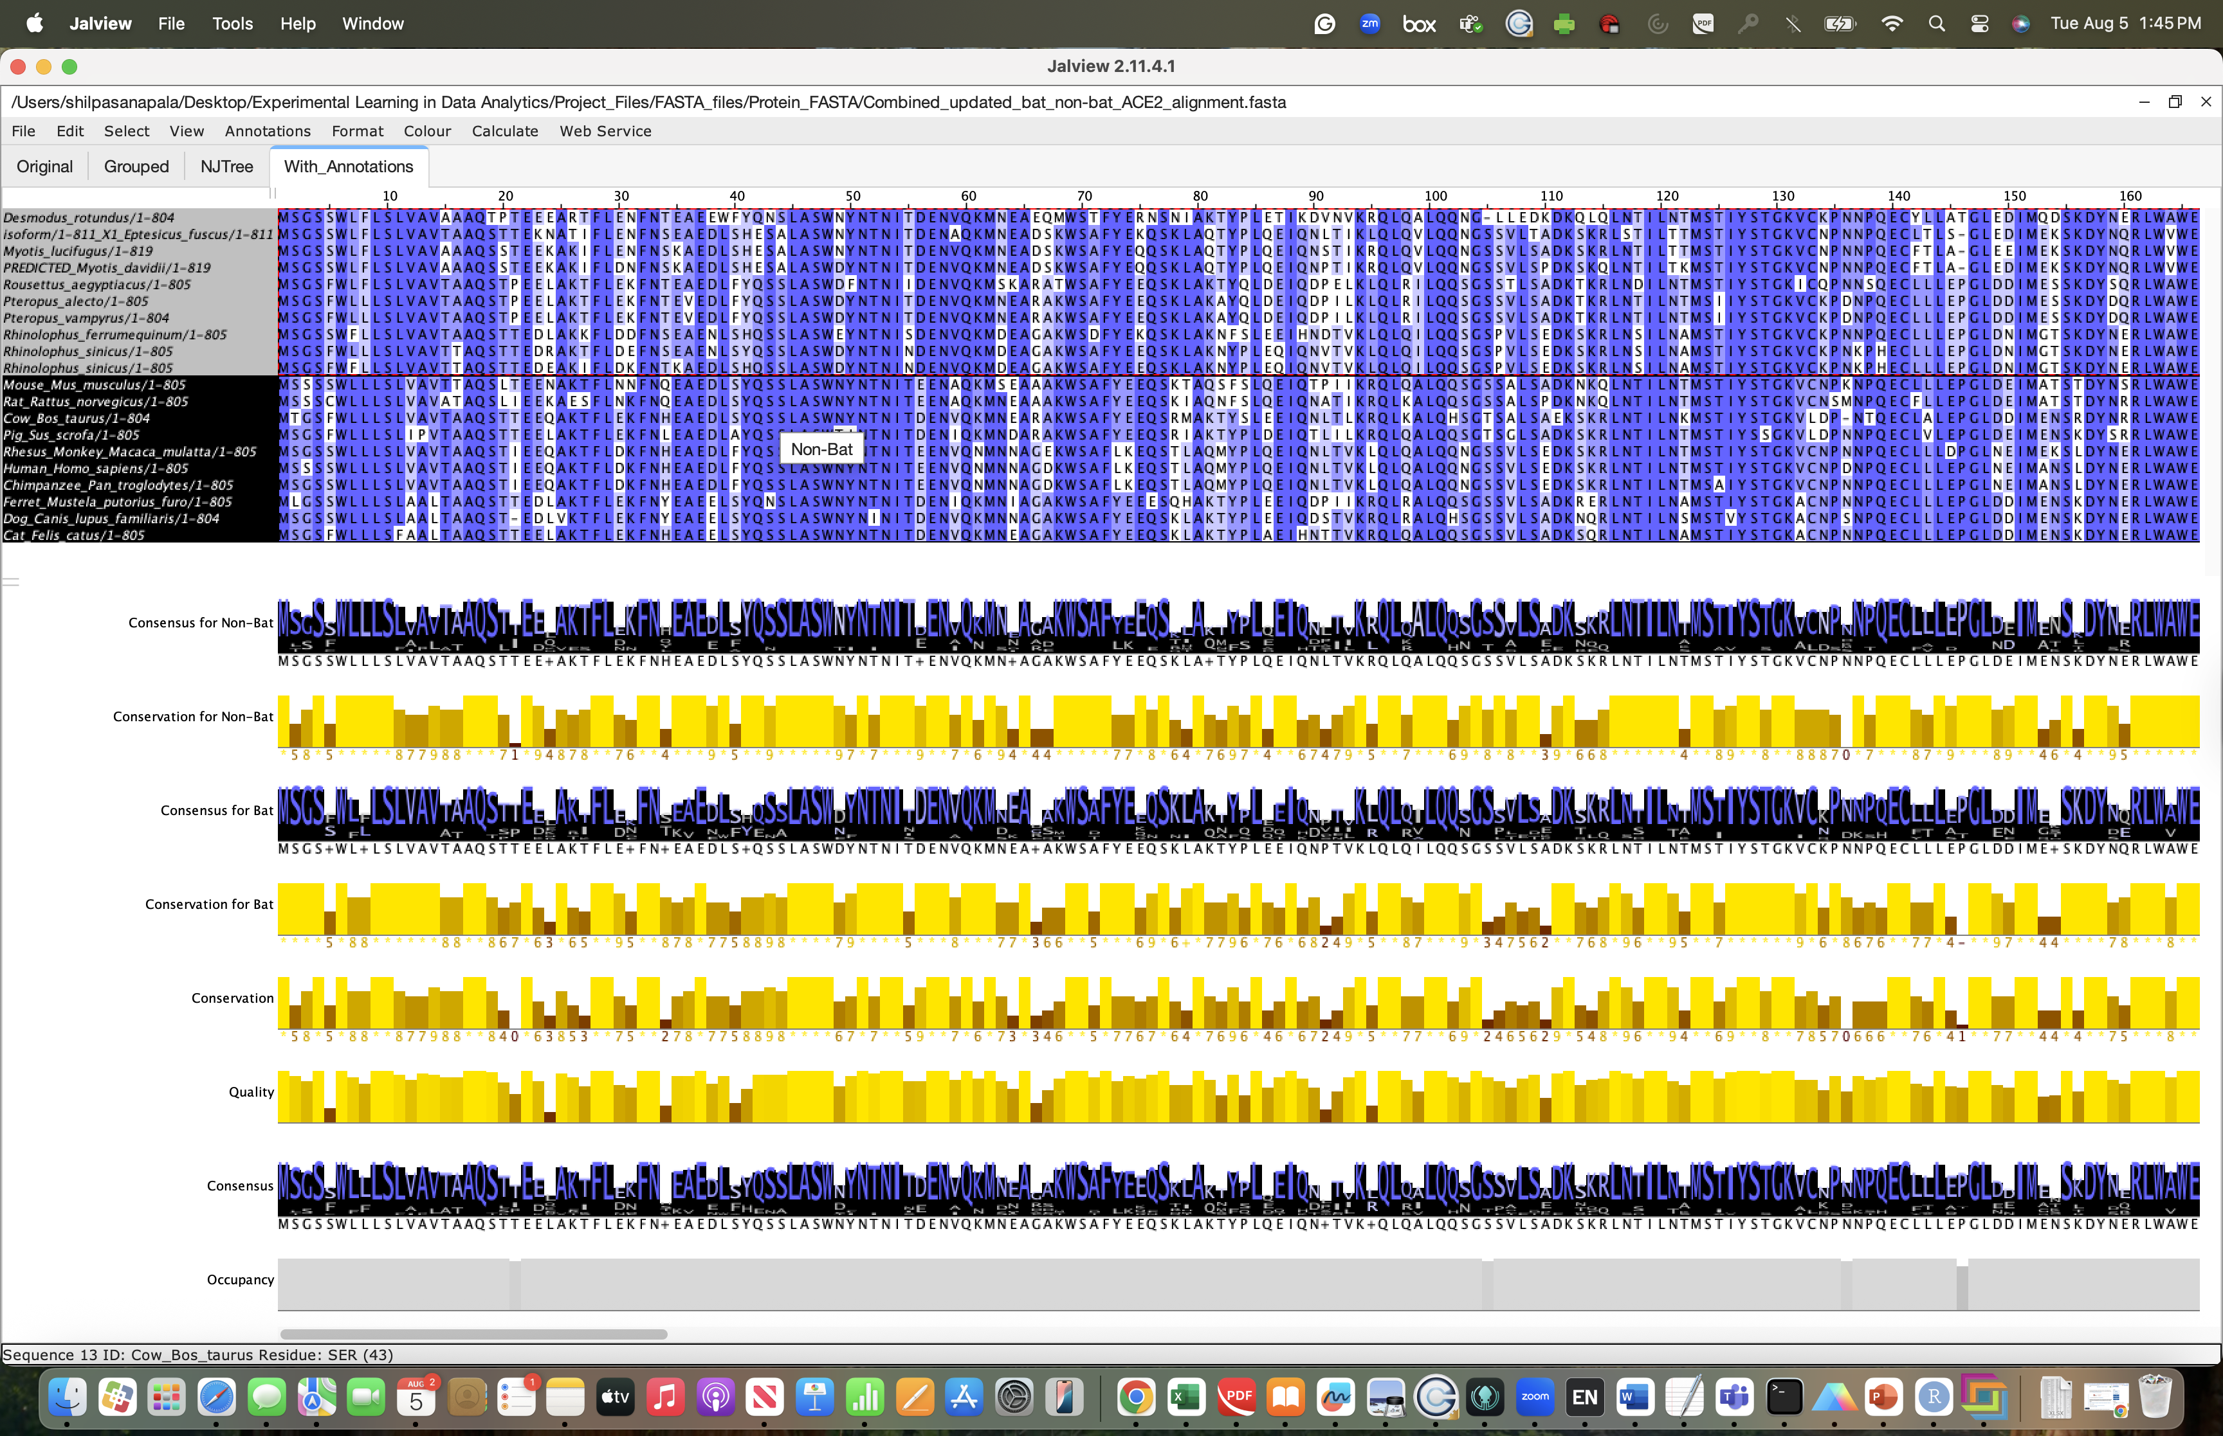

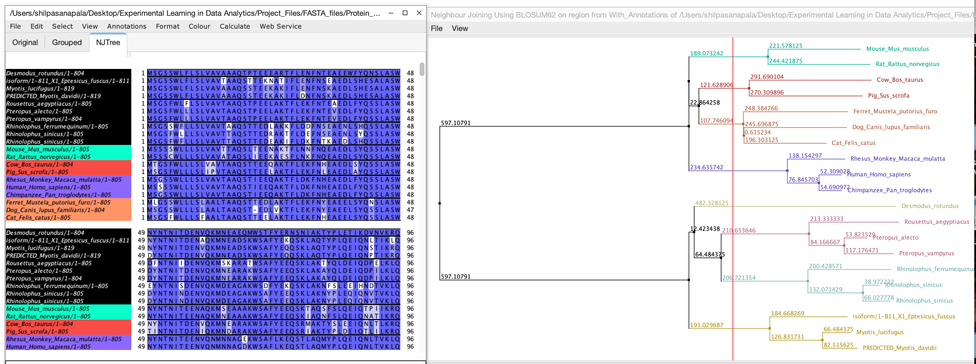

**Figure 4.** Alignment of bat and non-bat ACE2 protein sequences (combined visualization in Jalview) plus phylogenetic tree



**Figure 5.** Conservation heatmap and the corresponding bar graph showing conservation scores for bat and non-bat ACE2 aligned sequences per amino acid site on a scale of 0-11.

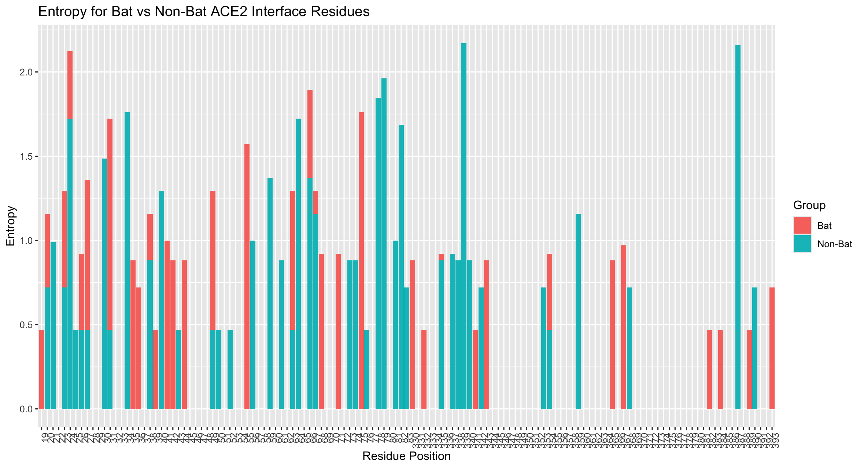

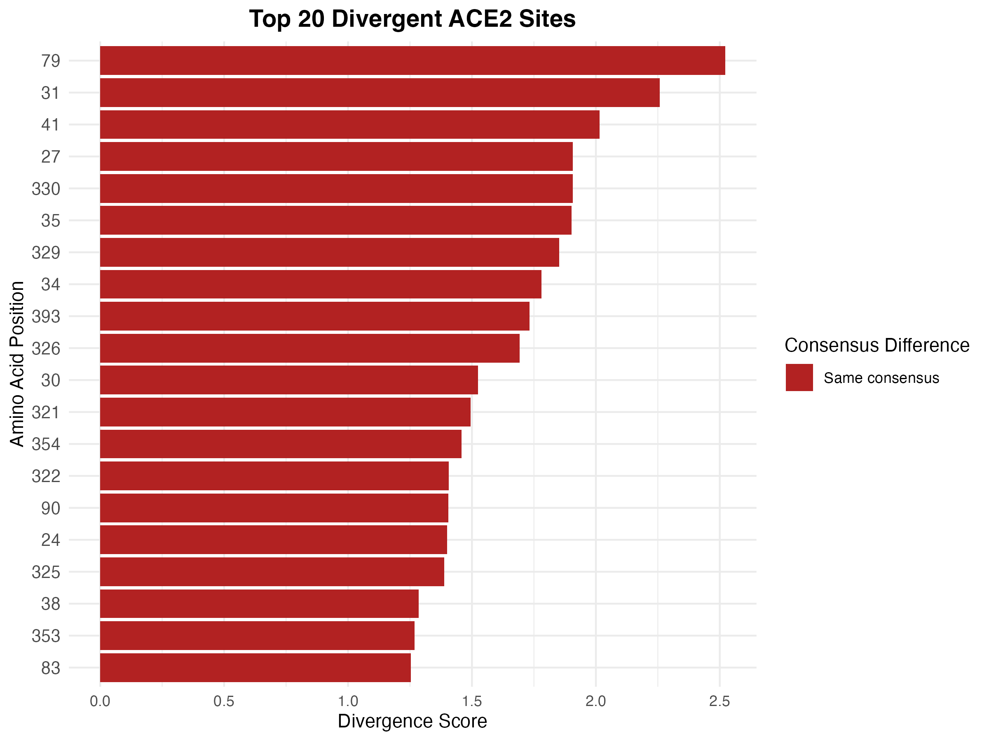

**Figure 6.** Entropy score and divergence metric plots for bat vs. non-bat ACE2 residue sites that contact virus spike region.